Parth Babbar

Mortgages in us

**Introduction:**

A mortgage is a loan used to buy or maintain real estate, and it requires the borrower to make regular principle and interest payments over time. Mortgages, a critical component of the US economy, allow individuals to become homeowners and investors to fund real estate initiatives. This presentation presents an in-depth overview of the US mortgage market, including mortgage kinds, application procedures, interest rates, market trends, and important statistics.

**Types of Mortgages:**

1. **Fixed-Rate Mortgages:** Fixed-rate mortgages feature an interest rate that remains consistent for the duration of the loan, ensuring predictable monthly payments. These loans are often repaid over 15, 20, or 30 years.  
   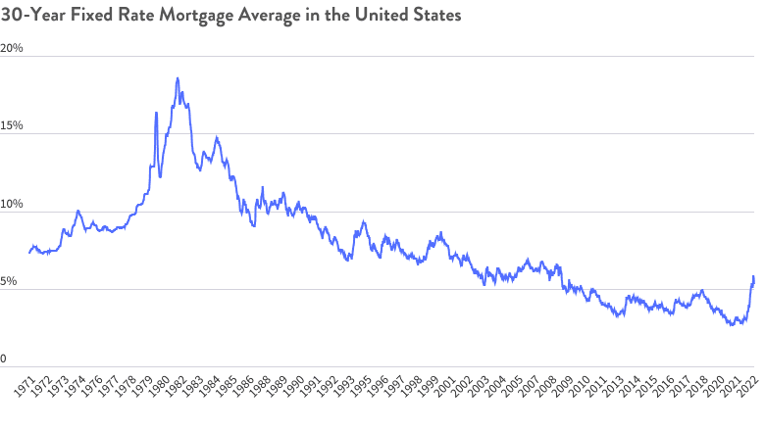  
   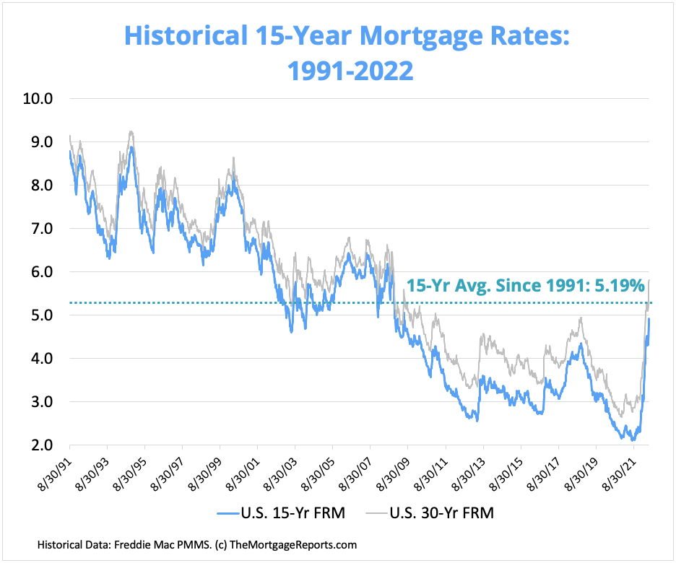
2. **Adjustable-Rate Mortgages:** Adjustable-rate mortgages (ARMs) feature interest rates that fluctuate depending on an index and frequently begin with a lower beginning rate than fixed-rate mortgages. Common adjustment times are 1, 3, 5, 7, or 10 Years.  
   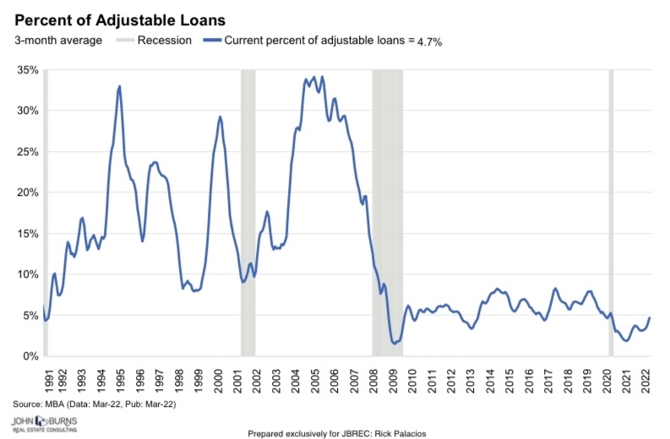
3. **Jumbo Loans:** Jumbo mortgages surpass the Federal Housing Finance Agency (FHFA) conforming loan ceilings, which are set at $766,550 or $1,149,825 in higher-cost locations for 2024. These bigger loans, which are not available through GSEs, finance more expensive properties at competitive rates, and are sometimes the only option in high-value areas. However, not all lenders provide them, with a minimum credit score of 700 and a 10% to 20% down payment.  
   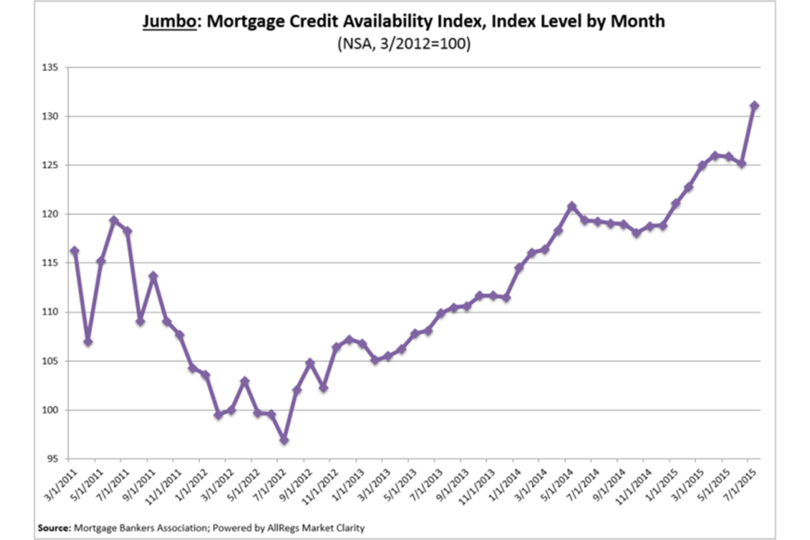

There are more types like conventional Loans, FHA, VA, etc.  
  
**Mortgages Process:**

1. **Pre-Approval:** Potential borrowers begin the mortgage process by submitting financial information to acquire a pre-approval letter that specifies the maximum amount they may borrow. This includes acquiring the required financial paperwork, monitoring their credit score, and creating a budget. A pre-approval letter helps purchasers by showing to sellers that they are serious about acquiring a home and have the financial means to do so.
2. **House Hunting:** When looking for a house, borrowers examine a variety of aspects, including location, price range, amenities, and property condition. They prioritise selecting houses that are within their price range and satisfy their requirements for location, amenities, and condition.
3. **Loan Application:** Borrowers must gather the following papers before applying for a mortgage: proof of income, employment verification, credit report, tax returns, and bank statements. Once finished, they send the application to their preferred lender. The lender next evaluates the paperwork and schedules an appraisal of the property to determine its worth.
4. **Loan Processing:** After receiving the borrower's application, the lender conducts underwriting, which involves assessing risk and verifying the veracity of the submitted information. Simultaneously, they request an independent evaluation of the property to ascertain its current worth.
5. **Closing:** Borrowers sign loan paperwork, pay closing fees, and complete the house purchase at the end of the mortgage process. Once the final loan documentation are completed, the mortgage is financed and the buyer takes title of the property.

**Interest Rates:**

Interest rates have a vital role in the mortgage industry. They have an impact on monthly payments as well as the total loan amount. Rates are affected by several factors, including:

1. Federal Reserve Policies
2. Home location
3. Credit Score
4. Loan Type and Term
5. Home price and loan amount
6. Down payment
7. Interest Rate Type

**Trends:**

1. **Rising Home Prices:** As of Q1 2024, the median house price in the United States was at $420,800. This rise indicates the high demand and limited supply in the housing market.  
   A graph showing the growth of a company

   Description automatically generated
2. **Interest Rates Trend:** Mortgage rates have climbed since the middle of 2024, owing to Federal Reserve rate rises aimed at managing inflation. Currently, the average 30-year fixed mortgage rate is roughly 6.5 percent.  
   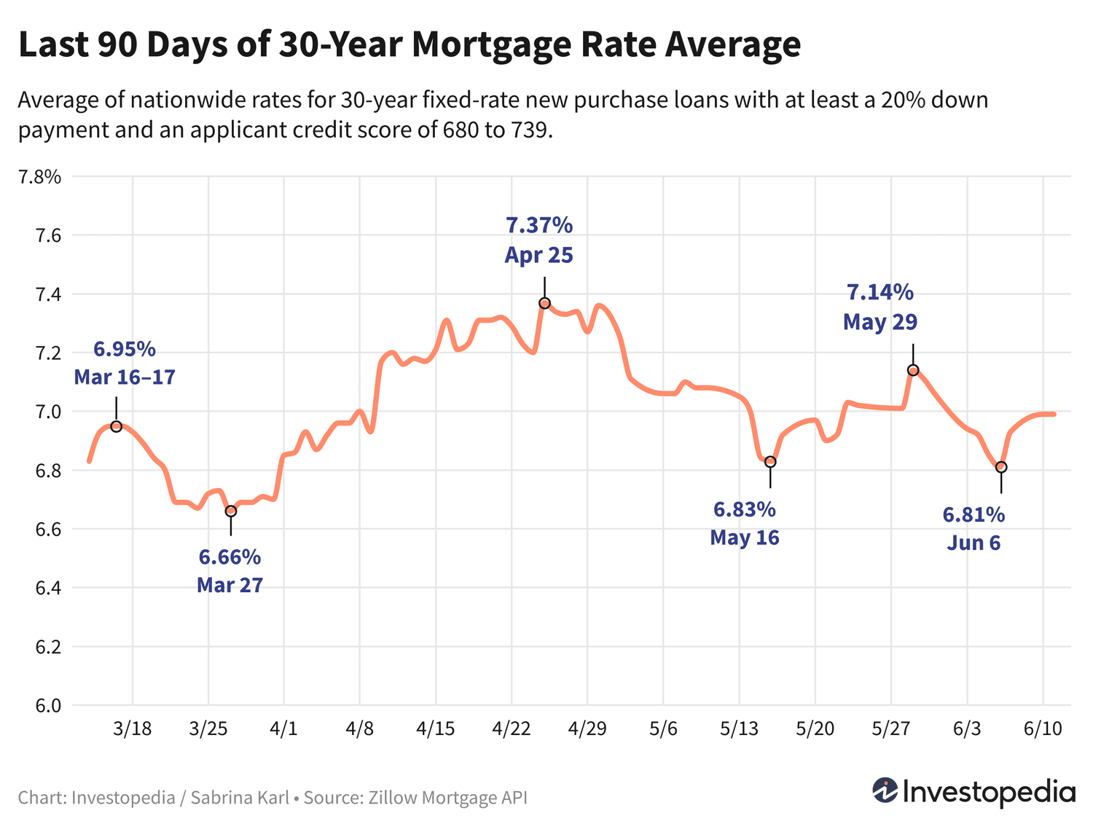
3. **Mortgage Origination Volume:** Higher interest rates have slowed refinancing activity, while buy originations remain strong. In 2023, the overall volume of mortgage origination was estimated to be $2.2 trillion. **A graph with blue lines

   Description automatically generated**
4. **Homeownership Rates:** The U.S. homeownership rate has been very stable, with only slight changes caused by economic conditions. As of Q1 2024, the homeownership rate is at 65.6%.  
   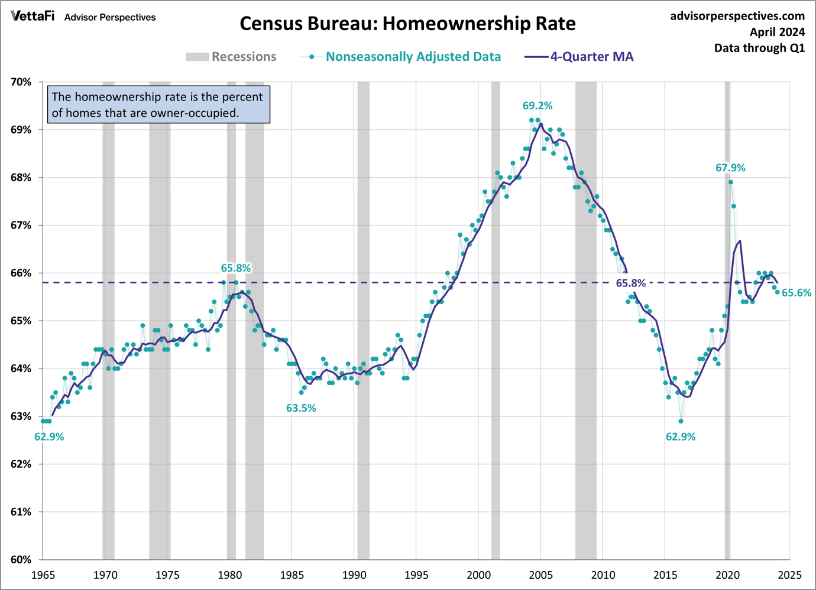

**Statistics:**

1. As of 2024, the total outstanding mortgage debt in the United States exceeds $12.44 trillion.  
     
   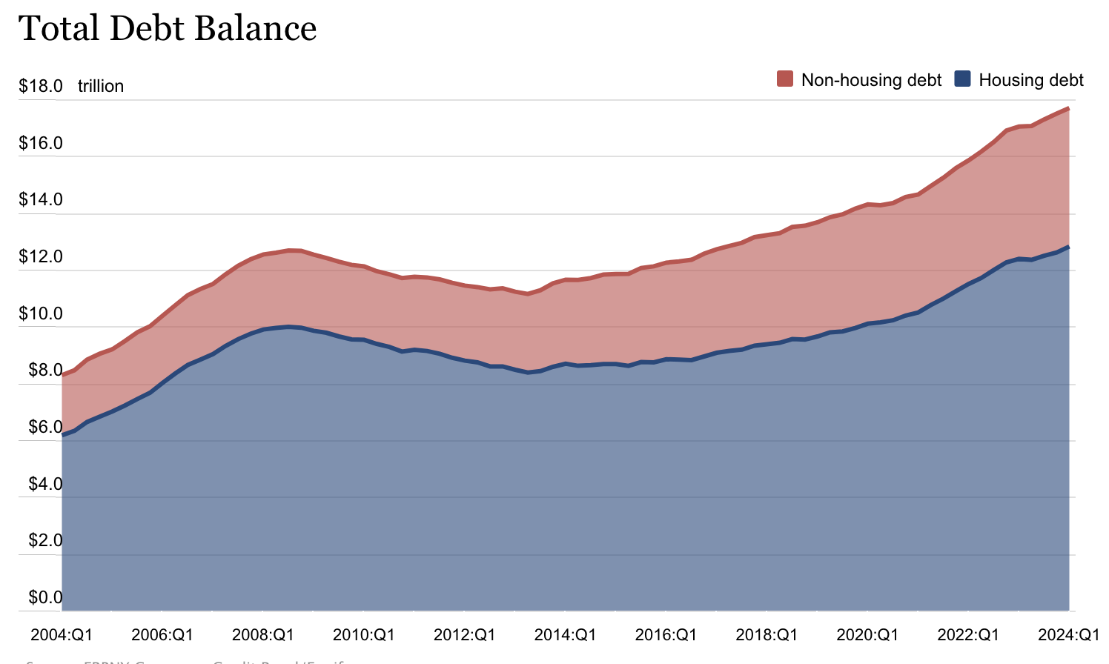
2. Mortgage delinquencies have decreased, indicating an economic rebound following the epidemic. As of Q1 2024, the mortgage delinquency rate is 1.71%.  
   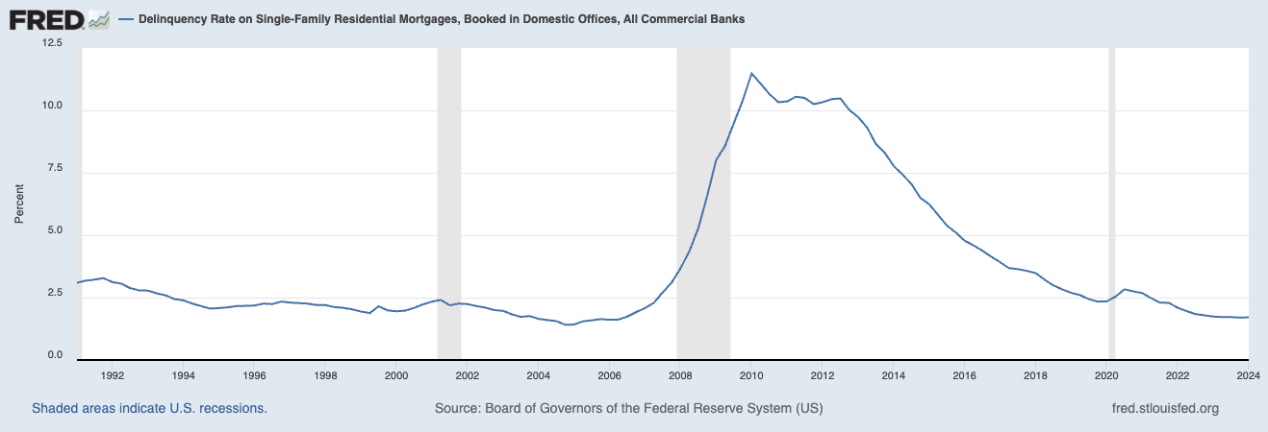

**Conclusion:**

The mortgage market in the United States is complicated and impacted by a variety of factors, including economic circumstances, interest rates, and government policy. Understanding mortgage kinds, the application procedure, and current market trends may help prospective homeowners make educated selections. As the market changes, both buyers and industry experts must keep updated about these variables.